Ayish Bayou Water Quality Monitoring Report

Michael Schramm 1, Lucas Gregory 2, Jeremiah Poling 3, Emylea Cole 3

1 Texas Water Resources Institute, Texas A&M AgriLife Research

2 Texas Water Resources Institute, Texas A&M AgriLife Extension Service

3 Angelina & Neches River Authority

April 1, 2021

Texas Water Resources Institute  
 Texas A&M AgriLife  
 College Station, TX

TR-ABCD

This project was funded through a grant from a generous agency.

Insert other funding or partnership acknowledgments here.

Table of Contents

Table of Figures

Table of Tables

Abbreviations

# Introduction

Work under this data collection project included water quality data collection in Ayish Bayou and its tributaries for future watershed planning efforts.  
Water quality data on the Ayish Bayou and its tributaries was collected to provide improved temporal and spatial data resolution for future watershed planning and assessment purposes. Water quality monitoring was conducted monthly at monitoring stations 15361, 15365, 21431, 22399 on TCEQ Segment 0610A (Ayish Bayou), 15358 on 0610K (Sandy Creek), 15359 on 0610I (Chiamon Creek), 15362 on 0610G (Caney Creek), and 15363 on 0610M (Venado Creek). The 2022 Texas Integrated Report on Water Quality provides the following segment descriptions:

* **0610A Ayish Bayou**: Perennial stream from the headwaters of Sam Rayburn Reservoir to the dam impounding Bland Lake approximately 0.1km upstream of FM 1279 near the City of San Augustine.
* **0610K Sandy Creek in San Augustine County**: From the confluence with Ayish Bayou (0610A) upstream to headwaters in San Augustine County.
* **0610I Chiamon Creek**: From the confluence with Ayish Bayou (0610A) in San Augustine County upstream to headwaters in Sabine County.
* **0610G Caney Creek in San Augustine County**: From the confluence with Ayish Bayou (0610A) in San Augustine County upstream to headwaters.
* **0610M Venado Creek**: From the confluence with Ayish Bayou (0610A) upstream to headwaters in San Augustine County.

Each water body is considered perennial with a “high” Aquatic Life Use designation. Ayish Bayou (0610A) has been identified as impaired in the 2022 Texas Integrated Report of Water Quality for exceeding the primary recreation use I criterion due to elevated *Escherichia coli* (*E. coli*) and was first listed impaired in 2000. Focus of the monitoring activities were for bacterial impairments, but other water quality parameters were collected to provide further information for planning efforts. Under this project sampling included collection of basic field parameters, conventional, and bacterialogical parameters. Sampling occurred monthly at all sites; however, sites 15361 and 21431 on Ayish Bayou were sampled quarterly under the previously planned quarterly Clean Rivers Program monitoring efforts. Quarterly samples are not included in this report. All work was conducted under an approved Quality Assurance Project Plan.

# Data Summary

This is an example of an unformatted table and how we cross-reference that table (Table ).

Table . Summary

| Parameter | n | Minimum | Maximum | Standard deviation | Centera |
| --- | --- | --- | --- | --- | --- |
| **SWQM Site: 15358 Sandy Creek - FM 705** | | | | | |
| CHLORIDE (MG/L AS CL) | 12 | 11 | 18 | 2.35 | 14.67 |
| E_ COLI, COLILERT, IDEXX METHOD, MPN/100ML | 12 | 23 | 2,400 | 924.9 | 245.05 |
| NITRATE NITROGEN, TOTAL (MG/L AS N) | 12 | 0.0322 | 0.086 | 0.01 | 0.05 |
| NITRITE NITROGEN, TOTAL (MG/L AS N) | 12 | 0.05 | 0.0882 | 0.01 | 0.05 |
| NITROGEN, AMMONIA, TOTAL (MG/L AS N) | 12 | 0.1 | 0.11 | 0 | 0.1 |
| NITROGEN, KJELDAHL, TOTAL (MG/L AS N) | 12 | 0.2 | 0.88 | 0.18 | 0.56 |
| OXYGEN, DISSOLVED (MG/L) | 12 | 4.3 | 10.7 | 1.96 | 6.67 |
| PH (STANDARD UNITS) | 12 | 6.2 | 7.7 | 0.35 | 6.82 |
| PHOSPHORUS, TOTAL, WET METHOD (MG/L AS P) | 12 | 0.0411 | 0.371 | 0.09 | 0.12 |
| RESIDUE, TOTAL NONFILTRABLE (MG/L) | 12 | 3.9 | 130 | 35.74 | 26.99 |
| SPECIFIC CONDUCTANCE,FIELD (UMHOS/CM @ 25C) | 12 | 112 | 175 | 22.27 | 143.17 |
| SULFATE (MG/L AS SO4) | 12 | 6.5 | 30 | 8.56 | 16.65 |
| TEMPERATURE, WATER (DEGREES CENTIGRADE) | 12 | 7.2 | 26.7 | 6.2 | 19.33 |
| TRANSPARENCY, SECCHI DISC (METERS) | 12 | 0.3 | 0.8 | 0.15 | 0.48 |
| **SWQM Site: 15359 Chiamon Bayou - FM 1751** | | | | | |
| CHLORIDE (MG/L AS CL) | 12 | 7.6 | 15 | 2.27 | 11.97 |
| E_ COLI, COLILERT, IDEXX METHOD, MPN/100ML | 12 | 45 | 2,400 | 686.86 | 253.19 |
| NITRATE NITROGEN, TOTAL (MG/L AS N) | 12 | 0.0464 | 0.087 | 0.01 | 0.06 |
| NITRITE NITROGEN, TOTAL (MG/L AS N) | 12 | 0.05 | 0.0882 | 0.01 | 0.05 |
| NITROGEN, AMMONIA, TOTAL (MG/L AS N) | 12 | 0.1 | 0.1 | 0 | 0.1 |
| NITROGEN, KJELDAHL, TOTAL (MG/L AS N) | 12 | 0.2 | 1.43 | 0.31 | 0.68 |
| OXYGEN, DISSOLVED (MG/L) | 12 | 1.1 | 10.5 | 3.25 | 5.06 |
| PH (STANDARD UNITS) | 12 | 6.4 | 7.7 | 0.33 | 6.87 |
| PHOSPHORUS, TOTAL, WET METHOD (MG/L AS P) | 12 | 0.0266 | 0.218 | 0.06 | 0.1 |
| RESIDUE, TOTAL NONFILTRABLE (MG/L) | 12 | 8 | 96 | 31.54 | 29.11 |
| SPECIFIC CONDUCTANCE,FIELD (UMHOS/CM @ 25C) | 12 | 110 | 223 | 31.1 | 181.75 |
| SULFATE (MG/L AS SO4) | 12 | 16 | 48 | 11.49 | 30.33 |
| TEMPERATURE, WATER (DEGREES CENTIGRADE) | 12 | 7.5 | 25.5 | 6 | 18.83 |
| TRANSPARENCY, SECCHI DISC (METERS) | 12 | 0.3 | 0.6 | 0.12 | 0.44 |
| **SWQM Site: 15361 AYISH BAYOU AT SH 103** | | | | | |
| CHLORIDE (MG/L AS CL) | 8 | 6.5 | 11 | 1.48 | 9.16 |
| E_ COLI, COLILERT, IDEXX METHOD, MPN/100ML | 8 | 32 | 2,400 | 777.79 | 282.15 |
| NITRATE NITROGEN, TOTAL (MG/L AS N) | 8 | 0.12 | 0.36 | 0.09 | 0.23 |
| NITRITE NITROGEN, TOTAL (MG/L AS N) | 8 | 0.05 | 0.05 | 0 | 0.05 |
| NITROGEN, AMMONIA, TOTAL (MG/L AS N) | 8 | 0.1 | 0.1 | 0 | 0.1 |
| NITROGEN, KJELDAHL, TOTAL (MG/L AS N) | 8 | 0.214 | 0.957 | 0.29 | 0.59 |
| OXYGEN, DISSOLVED (MG/L) | 8 | 4.9 | 10.1 | 1.72 | 6.81 |
| PH (STANDARD UNITS) | 8 | 6.9 | 7.4 | 0.18 | 7.18 |
| PHOSPHORUS, TOTAL, WET METHOD (MG/L AS P) | 8 | 0.042 | 0.409 | 0.12 | 0.11 |
| RESIDUE, TOTAL NONFILTRABLE (MG/L) | 8 | 5 | 140 | 46.31 | 25.94 |
| SPECIFIC CONDUCTANCE,FIELD (UMHOS/CM @ 25C) | 8 | 108 | 288 | 57.66 | 162.38 |
| SULFATE (MG/L AS SO4) | 8 | 5.6 | 17 | 3.87 | 11.12 |
| TEMPERATURE, WATER (DEGREES CENTIGRADE) | 8 | 10.1 | 26.8 | 5.78 | 19.75 |
| TRANSPARENCY, SECCHI DISC (METERS) | 8 | 0.2 | 0.5 | 0.09 | 0.4 |
| **SWQM Site: 15362 Caney Creek - SH 147** | | | | | |
| CHLORIDE (MG/L AS CL) | 12 | 7 | 10 | 0.96 | 8.92 |
| E_ COLI, COLILERT, IDEXX METHOD, MPN/100ML | 12 | 86 | 1,100 | 280.51 | 338.56 |
| NITRATE NITROGEN, TOTAL (MG/L AS N) | 12 | 0.0464 | 0.62 | 0.19 | 0.22 |
| NITRITE NITROGEN, TOTAL (MG/L AS N) | 12 | 0.05 | 0.0882 | 0.01 | 0.05 |
| NITROGEN, AMMONIA, TOTAL (MG/L AS N) | 12 | 0.1 | 0.1 | 0 | 0.1 |
| NITROGEN, KJELDAHL, TOTAL (MG/L AS N) | 12 | 0.2 | 1 | 0.21 | 0.48 |
| OXYGEN, DISSOLVED (MG/L) | 12 | 2.5 | 11.1 | 2.56 | 6.25 |
| PH (STANDARD UNITS) | 12 | 6.8 | 7.5 | 0.21 | 7.18 |
| PHOSPHORUS, TOTAL, WET METHOD (MG/L AS P) | 12 | 0.0182 | 0.125 | 0.03 | 0.06 |
| RESIDUE, TOTAL NONFILTRABLE (MG/L) | 12 | 2.6 | 63 | 16.43 | 13.63 |
| SPECIFIC CONDUCTANCE,FIELD (UMHOS/CM @ 25C) | 12 | 143 | 255 | 30.58 | 197.92 |
| SULFATE (MG/L AS SO4) | 12 | 5 | 35 | 8.51 | 9.28 |
| TEMPERATURE, WATER (DEGREES CENTIGRADE) | 12 | 6.7 | 27.2 | 6.68 | 18.06 |
| TRANSPARENCY, SECCHI DISC (METERS) | 12 | 0.3 | 0.8 | 0.13 | 0.52 |
| **SWQM Site: 15363 Venado Creek - SH 147** | | | | | |
| CHLORIDE (MG/L AS CL) | 12 | 8.6 | 12 | 1.15 | 9.93 |
| E_ COLI, COLILERT, IDEXX METHOD, MPN/100ML | 12 | 100 | 2,400 | 697.94 | 445.51 |
| NITRATE NITROGEN, TOTAL (MG/L AS N) | 12 | 0.05 | 0.54 | 0.14 | 0.21 |
| NITRITE NITROGEN, TOTAL (MG/L AS N) | 12 | 0.05 | 0.0882 | 0.01 | 0.05 |
| NITROGEN, AMMONIA, TOTAL (MG/L AS N) | 12 | 0.1 | 0.1 | 0 | 0.1 |
| NITROGEN, KJELDAHL, TOTAL (MG/L AS N) | 12 | 0.155 | 1.14 | 0.27 | 0.33 |
| OXYGEN, DISSOLVED (MG/L) | 12 | 4.9 | 11.5 | 1.95 | 7.9 |
| PH (STANDARD UNITS) | 12 | 7 | 7.8 | 0.22 | 7.51 |
| PHOSPHORUS, TOTAL, WET METHOD (MG/L AS P) | 12 | 0.02 | 0.119 | 0.03 | 0.05 |
| RESIDUE, TOTAL NONFILTRABLE (MG/L) | 12 | 2.5 | 69 | 19.79 | 11.93 |
| SPECIFIC CONDUCTANCE,FIELD (UMHOS/CM @ 25C) | 12 | 201 | 341 | 40 | 259 |
| SULFATE (MG/L AS SO4) | 12 | 20 | 44 | 6.5 | 29.5 |
| TEMPERATURE, WATER (DEGREES CENTIGRADE) | 12 | 8.2 | 26.7 | 6.08 | 18.25 |
| TRANSPARENCY, SECCHI DISC (METERS) | 12 | 0.4 | 1 | 0.2 | 0.65 |
| **SWQM Site: 15365 Ayish Bayou - FM 3230** | | | | | |
| CHLORIDE (MG/L AS CL) | 11 | 5 | 8.2 | 1.06 | 6.41 |
| E_ COLI, COLILERT, IDEXX METHOD, MPN/100ML | 11 | 180 | 1,700 | 437.59 | 430.76 |
| NITRATE NITROGEN, TOTAL (MG/L AS N) | 11 | 0.0464 | 0.11 | 0.02 | 0.06 |
| NITRITE NITROGEN, TOTAL (MG/L AS N) | 11 | 0.05 | 0.0882 | 0.01 | 0.05 |
| NITROGEN, AMMONIA, TOTAL (MG/L AS N) | 11 | 0.1 | 0.1 | 0 | 0.1 |
| NITROGEN, KJELDAHL, TOTAL (MG/L AS N) | 11 | 0.05 | 0.885 | 0.22 | 0.4 |
| OXYGEN, DISSOLVED (MG/L) | 11 | 4.7 | 10.2 | 1.75 | 6.86 |
| PH (STANDARD UNITS) | 11 | 6.4 | 7.5 | 0.36 | 6.93 |
| PHOSPHORUS, TOTAL, WET METHOD (MG/L AS P) | 11 | 0.01 | 0.11 | 0.03 | 0.05 |
| RESIDUE, TOTAL NONFILTRABLE (MG/L) | 11 | 2.5 | 15 | 3.55 | 7.07 |
| SPECIFIC CONDUCTANCE,FIELD (UMHOS/CM @ 25C) | 11 | 51 | 114 | 18.88 | 77.09 |
| SULFATE (MG/L AS SO4) | 11 | 5 | 19 | 4.61 | 8.13 |
| TEMPERATURE, WATER (DEGREES CENTIGRADE) | 11 | 7.6 | 26.1 | 6.21 | 17.15 |
| TRANSPARENCY, SECCHI DISC (METERS) | 11 | 0.4 | 0.9 | 0.18 | 0.59 |
| **SWQM Site: 21431 Ayish Bayou at West Columbia St** | | | | | |
| CHLORIDE (MG/L AS CL) | 8 | 5.6 | 9.2 | 1.13 | 7.21 |
| E_ COLI, COLILERT, IDEXX METHOD, MPN/100ML | 8 | 260 | 1,400 | 394.57 | 509.37 |
| NITRATE NITROGEN, TOTAL (MG/L AS N) | 8 | 0.05 | 0.16 | 0.05 | 0.11 |
| NITRITE NITROGEN, TOTAL (MG/L AS N) | 8 | 0.05 | 0.05 | 0 | 0.05 |
| NITROGEN, AMMONIA, TOTAL (MG/L AS N) | 8 | 0.1 | 0.1 | 0 | 0.1 |
| NITROGEN, KJELDAHL, TOTAL (MG/L AS N) | 8 | 0.2 | 0.633 | 0.15 | 0.35 |
| OXYGEN, DISSOLVED (MG/L) | 8 | 7.2 | 10.4 | 1.23 | 8.38 |
| PH (STANDARD UNITS) | 8 | 7.1 | 8 | 0.29 | 7.35 |
| PHOSPHORUS, TOTAL, WET METHOD (MG/L AS P) | 8 | 0.025 | 0.0808 | 0.02 | 0.05 |
| RESIDUE, TOTAL NONFILTRABLE (MG/L) | 8 | 4 | 8.6 | 1.53 | 5.21 |
| SPECIFIC CONDUCTANCE,FIELD (UMHOS/CM @ 25C) | 8 | 71 | 146 | 23.66 | 103.25 |
| SULFATE (MG/L AS SO4) | 8 | 5 | 23 | 6.2 | 9.35 |
| TEMPERATURE, WATER (DEGREES CENTIGRADE) | 8 | 10.4 | 25.8 | 5.8 | 18.66 |
| TRANSPARENCY, SECCHI DISC (METERS) | 8 | 0.3 | 0.7 | 0.13 | 0.5 |
| **SWQM Site: 22399 Ayish Bayou - CR 313** | | | | | |
| CHLORIDE (MG/L AS CL) | 12 | 8.1 | 12 | 1.13 | 10.32 |
| E_ COLI, COLILERT, IDEXX METHOD, MPN/100ML | 12 | 100 | 2,400 | 659.95 | 316.69 |
| NITRATE NITROGEN, TOTAL (MG/L AS N) | 12 | 0.0464 | 0.37 | 0.11 | 0.2 |
| NITRITE NITROGEN, TOTAL (MG/L AS N) | 12 | 0.05 | 0.0882 | 0.01 | 0.05 |
| NITROGEN, AMMONIA, TOTAL (MG/L AS N) | 12 | 0.1 | 0.1 | 0 | 0.1 |
| NITROGEN, KJELDAHL, TOTAL (MG/L AS N) | 12 | 0.174 | 0.828 | 0.23 | 0.45 |
| OXYGEN, DISSOLVED (MG/L) | 12 | 5 | 10.8 | 1.76 | 7.34 |
| PH (STANDARD UNITS) | 12 | 7.1 | 7.7 | 0.17 | 7.32 |
| PHOSPHORUS, TOTAL, WET METHOD (MG/L AS P) | 12 | 0.0326 | 0.278 | 0.07 | 0.08 |
| RESIDUE, TOTAL NONFILTRABLE (MG/L) | 12 | 6.9 | 130 | 34.28 | 26.18 |
| SPECIFIC CONDUCTANCE,FIELD (UMHOS/CM @ 25C) | 12 | 124 | 215 | 29.34 | 164.08 |
| SULFATE (MG/L AS SO4) | 12 | 6.3 | 20 | 4.53 | 13.33 |
| TEMPERATURE, WATER (DEGREES CENTIGRADE) | 12 | 7.7 | 26.6 | 6.17 | 19.22 |
| TRANSPARENCY, SECCHI DISC (METERS) | 12 | 0.3 | 0.7 | 0.12 | 0.47 |
| aCenter refers to the geometric mean for *E. coli* and the mean for all other parameters. | | | | | |

# Figures

We can embed and cross-reference plots (Figure ).

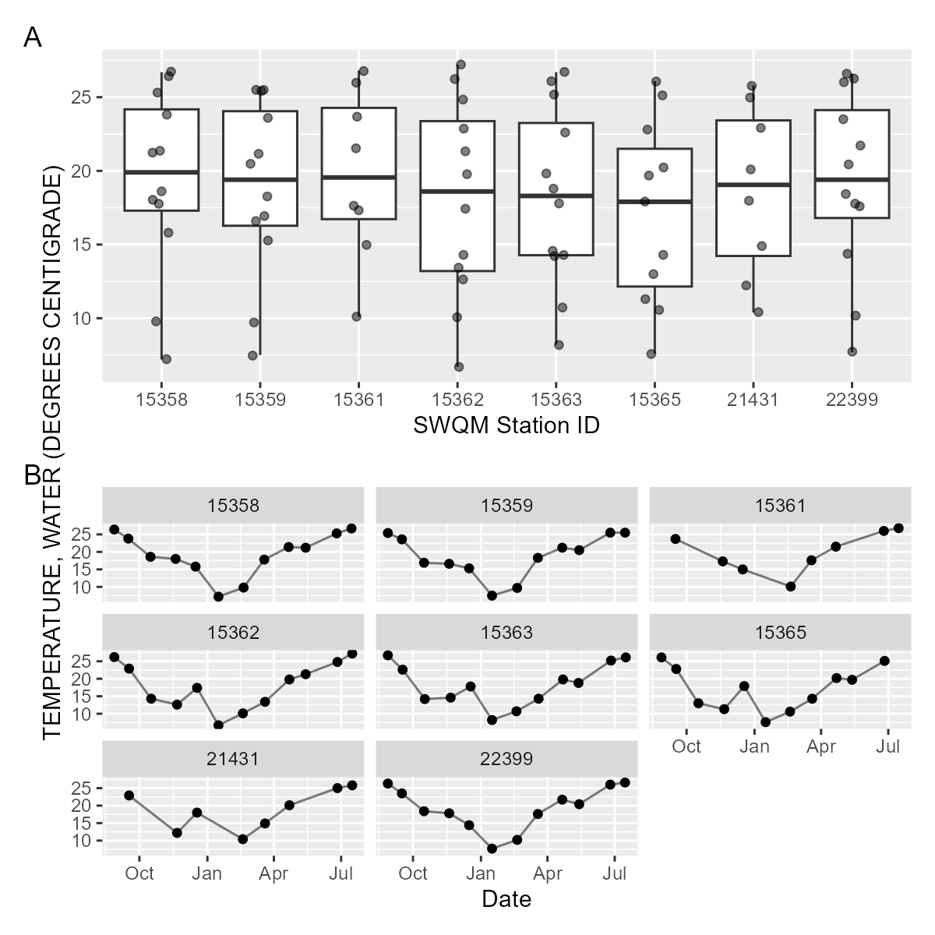

Figure . Temperature

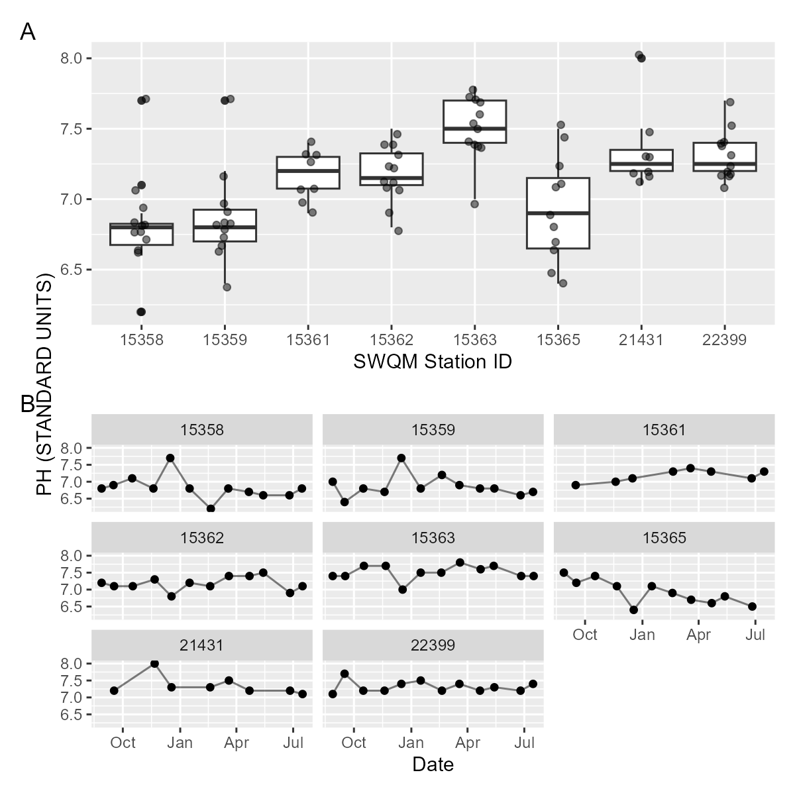

Figure . pH

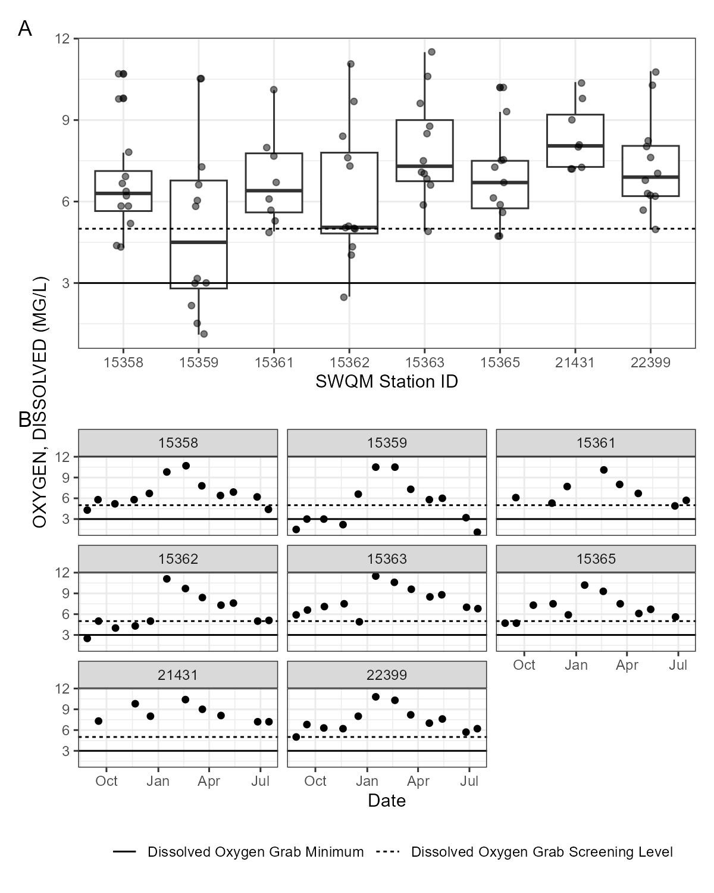

Figure . Grab Dissolved Oxygen samples by (A) station and by (B) date. Dissolved Oxygen grab minimum and screening level criterion are indicated by the solid and dashed lines.

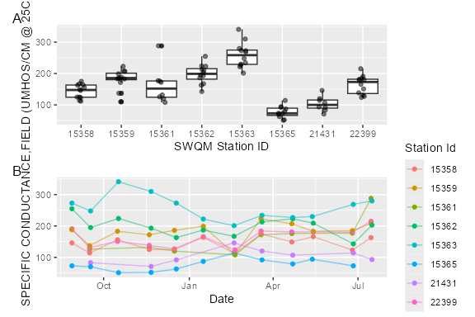

Figure . Specific conductance

## Warning: The shape palette can deal with a maximum of 6 discrete values because more  
## than 6 becomes difficult to discriminate  
## ℹ you have requested 8 values. Consider specifying shapes manually if you need  
## that many have them.

## Warning: Removed 20 rows containing missing values or values outside the scale range  
## (`geom_point()`).

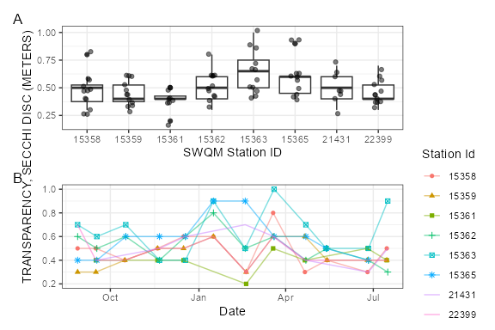

Figure . Transparency

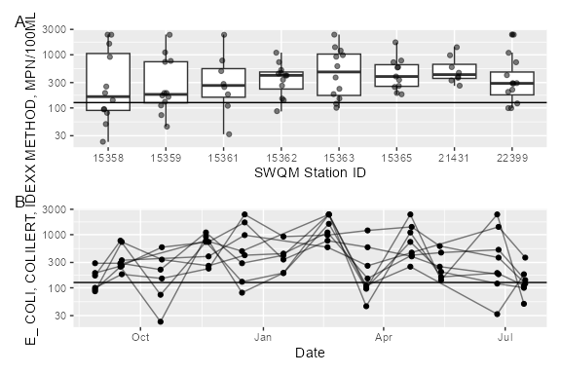

Figure . Ecoli

# Landscape Section

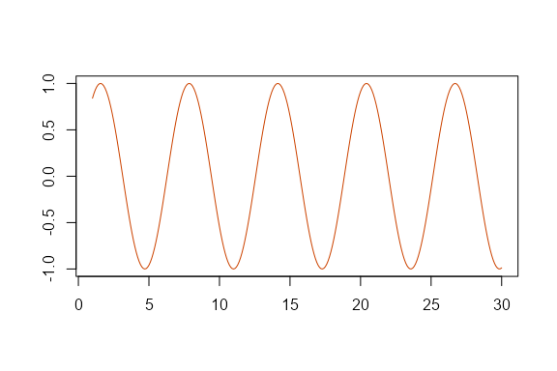

Figure . sin function

# Math

Wrap variables or math in a single $ to show math inline. For example, $ε∼N\left(0,1\right)$. Standalone equations are wrapped with $$.

$${\left(\prod_{i=1}^{n}{y_{i}}\right)}^{\frac{1}{n}}=exp\left[\frac{1}{n}\sum_{i=1}^{n}{log}y_{i}\right], \text{when} y_{1},y_{2},...,y_{n}>0$$

If the equations need to be numbered and cross-referenced the format as:

\begin{equation}  
\left(\prod_{i=1}^{n}y_i\right)^{\frac{1}{n}} = \exp\left[\frac{1}{n}\sum_{i=1}^n\log{y_i}\right], \quad \textrm{when} \quad y_1, y_2, ..., y_n > 0  
(\#eq:gmean)  
\end{equation}

Which renders as (Equation @ref(eq:gmean):

# References

In-text references and bibliography generation are handled automatically. It relies on creating a bibtex .bib file with your references. Software such as Zotero, Mendely, and even Google Scholar can generate the bibtex entries for you. The entries are stored in the bibliography.bib file inside the same directory as this .Rmd file. To make a in text citation, use the following syntax, [@helsel_statistical_2002] to generate the reference at the end of this sentence (Helsel and Hirsch 2002). Use a semicolon to include multiple references [@helsel_statistical_2002; @hirsch2010weighted] (Helsel and Hirsch 2002; Hirsch et al. 2010). Or we might use @helsel_statistical_2002 without brackets to indicate Helsel and Hirsch (2002) provide a fundamental overview of water quality statistics. The bibliography will populate automatically.

# Styling and fonts

This template uses Minion Pro for body fonts and Open Sans for headings following TWRI brand guidance and AgriLife brand guidance. I can’t bundle Minion Pro in this package because of licensing, but you can download and install both fonts from AgriLife (<https://agrilife.tamu.edu/wp-content/uploads/2021/03/AgriFonts.zip>). I recommend downloading and installing the fonts before knitting your documents. Note that Minion Pro won’t “embed” in Word documents because it is an OTF style font and currently Word only embeds TTF fonts. That means collaborators without the font installed on their system will see a different serif font on their system in Word. Once exported to pdf, both OTF and TTF fonts should be embedded correctly.

# Bibliography

Helsel D, Hirsch R. 2002. Statistical methods in water resources. U.S. Geological Survey (Techniques of water-resources investigations of the United States Geologic Survey). <http://water.usgs.gov/pubs/twri/twri4a3/>.

Hirsch RM, Moyer DL, Archfield SA. 2010. Weighted regressions on time, discharge, and season (WRTDS), with an application to Chesapeake Bay river inputs. JAWRA Journal of the American Water Resources Association. 46(5):857–880. doi:[10.1111/j.1752-1688.2010.00482.x](https://doi.org/10.1111/j.1752-1688.2010.00482.x).

# Appendix A

## Ayish Bayou 0610A

| **SWQM Station** | **Station Description** | **Date** | **OXYGEN, DISSOLVED (MG/L)** | **E. COLI, COLILERT, IDEXX METHOD (MPN/100ML)** | **CHLORIDE (MG/L AS CL)** | **NITRATE NITROGEN, TOTAL (MG/L AS N)** | **NITRITE NITROGEN, TOTAL (MG/L AS N)** | **NITROGEN, AMMONIA, TOTAL (MG/L AS N)** | **NITROGEN, KJELDAHL, TOTAL (MG/L AS N)** | **PHOSPHORUS, TOTAL, WET METHOD (MG/L AS P)** | **RESIDUE, TOTAL NONFILTRABLE (MG/L)** | **SULFATE (MG/L AS SO4)** |
| --- | --- | --- | --- | --- | --- | --- | --- | --- | --- | --- | --- | --- |
| 22399 | Ayish Bayou - CR 313 | 2024-08-28 | 5 | 290 | 10 | 0.1 | <0.05 | <0.1 | 0.229 | 0.0952 | 9 | 11 |
| 15365 | Ayish Bayou - FM 3230 | 2024-08-28 | 4.7 | 190 | 5 | <0.05 | <0.05 | <0.1 | <0.05 | 0.11 | 15 | <5 |
| 15361 | AYISH BAYOU AT SH 103 | 2024-09-16 | 6.1 | 280 | 7.4 | 0.13 | <0.05 | <0.1 | 0.46 | 0.048 | 8.6 | 8.8 |
| 22399 | Ayish Bayou - CR 313 | 2024-09-16 | 6.8 | 290 | 8.1 | 0.14 | <0.05 | <0.1 | 0.4 | 0.049 | 8.3 | 9.5 |
| 21431 | Ayish Bayou at West Columbia St | 2024-09-17 | 7.3 | 330 | 5.6 | 0.067 | <0.05 | <0.1 | 0.36 | 0.033 | 5.8 | <5 |
| 15365 | Ayish Bayou - FM 3230 | 2024-09-17 | 4.7 | 260 | 5.2 | <0.05 | <0.05 | <0.1 | 0.42 | 0.046 | 9.7 | <5 |
| 22399 | Ayish Bayou - CR 313 | 2024-10-16 | 6.3 | 220 | 9.9 | <0.0464 | <0.0882 | <0.1 | 0.174 | 0.048 | 10 | 7.2 |
| 15365 | Ayish Bayou - FM 3230 | 2024-10-17 | 7.3 | 580 | 5.1 | <0.0464 | <0.0882 | <0.1 | 0.328 | 0.037 | 7.1 | <5 |
| 15361 | AYISH BAYOU AT SH 103 | 2024-11-19 | 5.3 | 770 | 10 | 0.21 | <0.05 | <0.1 | 0.909 | 0.088 | 5 | 5.6 |
| 22399 | Ayish Bayou - CR 313 | 2024-11-19 | 6.2 | 1100 | 10 | 0.08 | <0.05 | <0.1 | 0.828 | 0.055 | 38 | 6.3 |
| 21431 | Ayish Bayou at West Columbia St | 2024-11-21 | 9.8 | 390 | 6.9 | <0.05 | <0.05 | <0.1 | <0.2 | 0.025 | 5 | <5 |
| 15365 | Ayish Bayou - FM 3230 | 2024-11-21 | 7.5 | 730 | 6.4 | <0.05 | <0.05 | <0.1 | 0.885 | 0.021 | 4.6 | <5 |
| 15361 | AYISH BAYOU AT SH 103 | 2024-12-16 | 7.7 | 490 | 10 | 0.12 | <0.05 | <0.1 | 0.214 | 0.094 | 5.7 | 9 |
| 22399 | Ayish Bayou - CR 313 | 2024-12-16 | 8 | 290 | 9.7 | 0.13 | <0.05 | <0.1 | <0.2 | 0.0724 | 6.9 | 11 |
| 21431 | Ayish Bayou at West Columbia St | 2024-12-18 | 8 | 980 | 7.4 | <0.05 | <0.05 | <0.1 | <0.2 | <0.06 | 4.5 | 6 |
| 15365 | Ayish Bayou - FM 3230 | 2024-12-18 | 5.9 | 1700 | 6.5 | <0.05 | <0.05 | <0.1 | <0.2 | <0.06 | 5.9 | <5 |
| 22399 | Ayish Bayou - CR 313 | 2025-01-16 | 10.8 | 410 | 11 | 0.37 | <0.05 | <0.1 | 0.41 | 0.0326 | 11 | 20 |
| 15365 | Ayish Bayou - FM 3230 | 2025-01-16 | 10.2 | 340 | 7.5 | 0.11 | <0.05 | <0.1 | 0.29 | <0.01 | <2.5 | 13 |
| 21431 | Ayish Bayou at West Columbia St | 2025-02-18 | 10.4 | 580 | 9.2 | 0.16 | <0.05 | <0.1 | <0.2 | 0.0808 | 4.2 | 23 |
| 15365 | Ayish Bayou - FM 3230 | 2025-02-18 | 9.3 | 770 | 8.2 | 0.084 | <0.05 | <0.1 | 0.3 | 0.0639 | 3.3 | 19 |
| 22399 | Ayish Bayou - CR 313 | 2025-02-19 | 10.3 | >2400 | 9.2 | 0.224 | <0.05 | <0.1 | 0.77 | 0.278 | 130 | 16 |
| 15361 | AYISH BAYOU AT SH 103 | 2025-02-19 | 10.1 | >2400 | 6.5 | 0.318 | <0.05 | <0.1 | 0.9 | 0.409 | 140 | 8.6 |
| 15361 | AYISH BAYOU AT SH 103 | 2025-03-19 | 8 | 110 | 9.8 | 0.18 | <0.05 | <0.1 | 0.44 | 0.073 | 13 | 15 |
| 22399 | Ayish Bayou - CR 313 | 2025-03-19 | 8.2 | 100 | 12 | 0.15 | <0.05 | <0.1 | 0.45 | <0.06 | 15 | 19 |
| 21431 | Ayish Bayou at West Columbia St | 2025-03-20 | 9 | 260 | 8.2 | 0.096 | <0.05 | <0.1 | 0.4 | <0.06 | 4 | 13 |
| 15365 | Ayish Bayou - FM 3230 | 2025-03-20 | 7.5 | 580 | 7.4 | <0.05 | <0.05 | <0.1 | 0.41 | <0.06 | 5.2 | 9.6 |
| 15361 | AYISH BAYOU AT SH 103 | 2025-04-21 | 6.7 | 250 | 9.3 | 0.36 | <0.05 | <0.1 | 0.957 | 0.079 | 19 | 14 |
| 22399 | Ayish Bayou - CR 313 | 2025-04-21 | 7 | 730 | 11 | 0.31 | <0.05 | <0.1 | 0.357 | 0.072 | 33 | 17 |
| 21431 | Ayish Bayou at West Columbia St | 2025-04-22 | 8.1 | 460 | 7.1 | 0.16 | <0.05 | <0.1 | 0.633 | 0.046 | 8.6 | 9.7 |
| 15365 | Ayish Bayou - FM 3230 | 2025-04-22 | 6.1 | 390 | 6.5 | 0.073 | <0.05 | <0.1 | 0.65 | 0.051 | 8.2 | 6.6 |
| 15365 | Ayish Bayou - FM 3230 | 2025-05-13 | 6.7 | 250 | 6.9 | 0.085 | <0.05 | <0.1 | 0.47 | <0.06 | 6.3 | 11 |
| 22399 | Ayish Bayou - CR 313 | 2025-05-14 | 7.6 | 200 | 10 | 0.3 | <0.05 | <0.1 | 0.36 | <0.06 | 27 | 17 |
| 15361 | AYISH BAYOU AT SH 103 | 2025-06-25 | 4.9 | 32 | 9.3 | 0.27 | <0.05 | <0.1 | 0.52 | 0.053 | 8.8 | 11 |
| 22399 | Ayish Bayou - CR 313 | 2025-06-25 | 5.7 | 120 | 11 | 0.23 | <0.05 | <0.1 | 0.8 | 0.058 | 15 | 12 |
| 21431 | Ayish Bayou at West Columbia St | 2025-06-26 | 7.2 | 1400 | 7.2 | 0.16 | <0.05 | <0.1 | 0.4 | 0.049 | 5.6 | 8.1 |
| 15365 | Ayish Bayou - FM 3230 | 2025-06-26 | 5.6 | 180 | 5.8 | 0.056 | <0.05 | <0.1 | 0.36 | 0.047 | 10 | 5.2 |
| 15361 | AYISH BAYOU AT SH 103 | 2025-07-15 | 5.7 | 180 | 11 | 0.29 | <0.05 | <0.1 | 0.35 | 0.042 | 7.4 | 17 |
| 22399 | Ayish Bayou - CR 313 | 2025-07-15 | 6.2 | 100 | 12 | 0.35 | <0.05 | <0.1 | 0.45 | 0.045 | 11 | 14 |
| 21431 | Ayish Bayou at West Columbia St | 2025-07-16 | 7.2 | 370 | 6.1 | 0.1 | <0.05 | <0.1 | 0.44 | 0.039 | 4 | <5 |

## CANEY BAYOU 0610G

| **SWQM Station** | **Station Description** | **Date** | **OXYGEN, DISSOLVED (MG/L)** | **E. COLI, COLILERT, IDEXX METHOD (MPN/100ML)** | **CHLORIDE (MG/L AS CL)** | **NITRATE NITROGEN, TOTAL (MG/L AS N)** | **NITRITE NITROGEN, TOTAL (MG/L AS N)** | **NITROGEN, AMMONIA, TOTAL (MG/L AS N)** | **NITROGEN, KJELDAHL, TOTAL (MG/L AS N)** | **PHOSPHORUS, TOTAL, WET METHOD (MG/L AS P)** | **RESIDUE, TOTAL NONFILTRABLE (MG/L)** | **SULFATE (MG/L AS SO4)** |
| --- | --- | --- | --- | --- | --- | --- | --- | --- | --- | --- | --- | --- |
| 15362 | Caney Creek - SH 147 | 2024-08-28 | 2.5 | 86 | 9.1 | 0.054 | <0.05 | <0.1 | 0.23 | 0.0182 | 7.9 | <5 |
| 15362 | Caney Creek - SH 147 | 2024-09-17 | 5 | 730 | 7.2 | 0.11 | <0.05 | <0.1 | 0.44 | 0.037 | 10 | 5.7 |
| 15362 | Caney Creek - SH 147 | 2024-10-17 | 4 | 340 | 9 | <0.0464 | <0.0882 | <0.1 | 0.654 | 0.043 | 17 | <5 |
| 15362 | Caney Creek - SH 147 | 2024-11-21 | 4.3 | 260 | 10 | <0.05 | <0.05 | <0.1 | 0.356 | 0.047 | 2.9 | 35 |
| 15362 | Caney Creek - SH 147 | 2024-12-18 | 5 | 410 | 9.6 | <0.05 | <0.05 | <0.1 | <0.2 | <0.06 | 4.9 | 14 |
| 15362 | Caney Creek - SH 147 | 2025-01-16 | 11.1 | 440 | 10 | 0.62 | <0.05 | <0.1 | 0.39 | 0.0242 | 2.6 | 9.7 |
| 15362 | Caney Creek - SH 147 | 2025-02-18 | 9.7 | 1100 | 8.6 | 0.44 | <0.05 | <0.1 | 0.61 | 0.125 | 8.8 | 7.9 |
| 15362 | Caney Creek - SH 147 | 2025-03-20 | 8.4 | 150 | 9.3 | 0.16 | <0.05 | <0.1 | 0.48 | <0.06 | 7.7 | 6.4 |
| 15362 | Caney Creek - SH 147 | 2025-04-22 | 7.3 | 410 | 8.8 | 0.36 | <0.05 | <0.1 | 0.374 | 0.085 | 63 | 6.2 |
| 15362 | Caney Creek - SH 147 | 2025-05-14 | 7.6 | 460 | 8.8 | 0.37 | <0.05 | <0.1 | 0.47 | <0.06 | 18 | 6.1 |
| 15362 | Caney Creek - SH 147 | 2025-06-26 | 5 | 520 | 7 | 0.15 | <0.05 | <0.1 | 1 | 0.088 | 16 | <5 |
| 15362 | Caney Creek - SH 147 | 2025-07-16 | 5.1 | 140 | 9.6 | 0.22 | <0.05 | <0.1 | 0.51 | 0.05 | 4.8 | 5.3 |

## CHIAMON BAYOU 0610I

| **SWQM Station** | **Station Description** | **Date** | **OXYGEN, DISSOLVED (MG/L)** | **E. COLI, COLILERT, IDEXX METHOD (MPN/100ML)** | **CHLORIDE (MG/L AS CL)** | **NITRATE NITROGEN, TOTAL (MG/L AS N)** | **NITRITE NITROGEN, TOTAL (MG/L AS N)** | **NITROGEN, AMMONIA, TOTAL (MG/L AS N)** | **NITROGEN, KJELDAHL, TOTAL (MG/L AS N)** | **PHOSPHORUS, TOTAL, WET METHOD (MG/L AS P)** | **RESIDUE, TOTAL NONFILTRABLE (MG/L)** | **SULFATE (MG/L AS SO4)** |
| --- | --- | --- | --- | --- | --- | --- | --- | --- | --- | --- | --- | --- |
| 15359 | Chiamon Bayou - FM 1751 | 2024-08-28 | 1.5 | 170 | 12 | <0.05 | <0.05 | <0.1 | 0.71 | 0.163 | 23 | 21 |
| 15359 | Chiamon Bayou - FM 1751 | 2024-09-16 | 3 | 770 | 7.6 | 0.078 | <0.05 | <0.1 | 0.68 | 0.079 | 26 | 24 |
| 15359 | Chiamon Bayou - FM 1751 | 2024-10-16 | 3 | 74 | 10 | <0.0464 | <0.0882 | <0.1 | 0.766 | 0.063 | 8 | 22 |
| 15359 | Chiamon Bayou - FM 1751 | 2024-11-19 | 2.2 | 730 | 12 | <0.05 | <0.05 | <0.1 | 0.809 | 0.075 | 9.7 | 16 |
| 15359 | Chiamon Bayou - FM 1751 | 2024-12-16 | 6.6 | 130 | 11 | <0.05 | <0.05 | <0.1 | <0.2 | 0.07 | 8.3 | 46 |
| 15359 | Chiamon Bayou - FM 1751 | 2025-01-16 | 10.5 | 190 | 15 | 0.059 | <0.05 | <0.1 | 0.42 | 0.0266 | 8.3 | 46 |
| 15359 | Chiamon Bayou - FM 1751 | 2025-02-19 | 10.5 | >2400 | 9.1 | 0.0848 | <0.05 | <0.1 | 0.78 | 0.218 | 96 | 20 |
| 15359 | Chiamon Bayou - FM 1751 | 2025-03-19 | 7.3 | 45 | 15 | <0.05 | <0.05 | <0.1 | 0.4 | 0.163 | 12 | 48 |
| 15359 | Chiamon Bayou - FM 1751 | 2025-04-21 | 5.8 | 1100 | 13 | <0.05 | <0.05 | <0.1 | 1.43 | 0.081 | 22 | 38 |
| 15359 | Chiamon Bayou - FM 1751 | 2025-05-14 | 6 | 160 | 13 | 0.062 | <0.05 | <0.1 | 0.84 | <0.06 | 94 | 33 |
| 15359 | Chiamon Bayou - FM 1751 | 2025-06-25 | 3.2 | 190 | 12 | 0.087 | <0.05 | <0.1 | 0.55 | 0.075 | 26 | 28 |
| 15359 | Chiamon Bayou - FM 1751 | 2025-07-15 | 1.1 | 110 | 14 | 0.054 | <0.05 | <0.1 | 0.52 | 0.071 | 16 | 22 |

## SANDY CREEK 0610K

| **SWQM Station** | **Station Description** | **Date** | **OXYGEN, DISSOLVED (MG/L)** | **E. COLI, COLILERT, IDEXX METHOD (MPN/100ML)** | **CHLORIDE (MG/L AS CL)** | **NITRATE NITROGEN, TOTAL (MG/L AS N)** | **NITRITE NITROGEN, TOTAL (MG/L AS N)** | **NITROGEN, AMMONIA, TOTAL (MG/L AS N)** | **NITROGEN, KJELDAHL, TOTAL (MG/L AS N)** | **PHOSPHORUS, TOTAL, WET METHOD (MG/L AS P)** | **RESIDUE, TOTAL NONFILTRABLE (MG/L)** | **SULFATE (MG/L AS SO4)** |
| --- | --- | --- | --- | --- | --- | --- | --- | --- | --- | --- | --- | --- |
| 15358 | Sandy Creek - FM 705 | 2024-08-28 | 4.3 | 93 | 13 | 0.061 | <0.05 | 0.11 | 0.575 | 0.0976 | 26 | 8.8 |
| 15358 | Sandy Creek - FM 705 | 2024-09-16 | 5.8 | 250 | 11 | 0.054 | <0.05 | <0.1 | 0.61 | 0.084 | 47 | 10 |
| 15358 | Sandy Creek - FM 705 | 2024-10-16 | 5.2 | 23 | 16 | <0.0464 | <0.0882 | <0.1 | 0.613 | 0.065 | 7.7 | 7.5 |
| 15358 | Sandy Creek - FM 705 | 2024-11-19 | 5.8 | 920 | 14 | <0.05 | <0.05 | <0.1 | 0.701 | 0.065 | 9 | 6.5 |
| 15358 | Sandy Creek - FM 705 | 2024-12-16 | 6.7 | 81 | 13 | <0.05 | <0.05 | <0.1 | <0.2 | 0.145 | 5.9 | 12 |
| 15358 | Sandy Creek - FM 705 | 2025-01-16 | 9.8 | 190 | 17 | <0.05 | <0.05 | <0.1 | 0.43 | 0.0411 | 7.3 | 30 |
| 15358 | Sandy Creek - FM 705 | 2025-02-19 | 10.7 | 1600 | 11 | 0.0322 | <0.05 | <0.1 | 0.68 | 0.371 | 130 | 24 |
| 15358 | Sandy Creek - FM 705 | 2025-03-19 | 7.8 | 96 | 18 | <0.05 | <0.05 | <0.1 | 0.48 | 0.151 | 8.1 | 28 |
| 15358 | Sandy Creek - FM 705 | 2025-04-21 | 6.4 | >2400 | 16 | 0.051 | <0.05 | <0.1 | 0.704 | 0.076 | 28 | 20 |
| 15358 | Sandy Creek - FM 705 | 2025-05-14 | 6.9 | 140 | 16 | <0.05 | <0.05 | <0.1 | 0.42 | <0.06 | 8 | 26 |
| 15358 | Sandy Creek - FM 705 | 2025-06-25 | 6.2 | >2400 | 14 | <0.05 | <0.05 | <0.1 | 0.88 | 0.15 | 43 | 16 |
| 15358 | Sandy Creek - FM 705 | 2025-07-15 | 4.4 | 50 | 17 | 0.086 | <0.05 | <0.1 | 0.46 | 0.077 | 3.9 | 11 |

## Venado Creek 0610M

| **SWQM Station** | **Station Description** | **Date** | **OXYGEN, DISSOLVED (MG/L)** | **E. COLI, COLILERT, IDEXX METHOD (MPN/100ML)** | **CHLORIDE (MG/L AS CL)** | **NITRATE NITROGEN, TOTAL (MG/L AS N)** | **NITRITE NITROGEN, TOTAL (MG/L AS N)** | **NITROGEN, AMMONIA, TOTAL (MG/L AS N)** | **NITROGEN, KJELDAHL, TOTAL (MG/L AS N)** | **PHOSPHORUS, TOTAL, WET METHOD (MG/L AS P)** | **RESIDUE, TOTAL NONFILTRABLE (MG/L)** | **SULFATE (MG/L AS SO4)** |
| --- | --- | --- | --- | --- | --- | --- | --- | --- | --- | --- | --- | --- |
| 15363 | Venado Creek - SH 147 | 2024-08-28 | 5.9 | 100 | 9.5 | 0.09 | <0.05 | <0.1 | 0.155 | 0.0339 | 3.5 | 28 |
| 15363 | Venado Creek - SH 147 | 2024-09-17 | 6.6 | 180 | 9 | 0.087 | <0.05 | <0.1 | <0.2 | <0.02 | 2.9 | 29 |
| 15363 | Venado Creek - SH 147 | 2024-10-17 | 7.1 | 150 | 8.6 | 0.0806 | <0.0882 | <0.1 | 0.218 | 0.028 | 4.7 | 44 |
| 15363 | Venado Creek - SH 147 | 2024-11-21 | 7.5 | 230 | 9.4 | 0.15 | <0.05 | <0.1 | <0.2 | <0.02 | 2.9 | 40 |
| 15363 | Venado Creek - SH 147 | 2024-12-18 | 4.9 | 2400 | 12 | <0.05 | <0.05 | <0.1 | 0.318 | <0.06 | 32 | 20 |
| 15363 | Venado Creek - SH 147 | 2025-01-16 | 11.5 | 920 | 10 | 0.54 | <0.05 | <0.1 | 0.26 | 0.0591 | 3.7 | 31 |
| 15363 | Venado Creek - SH 147 | 2025-02-18 | 10.6 | 980 | 8.9 | 0.37 | <0.05 | <0.1 | 0.33 | 0.119 | 11 | 26 |
| 15363 | Venado Creek - SH 147 | 2025-03-20 | 9.6 | 1200 | 10 | 0.13 | <0.05 | <0.1 | <0.2 | <0.06 | 2.5 | 29 |
| 15363 | Venado Creek - SH 147 | 2025-04-22 | 8.5 | 1400 | 9.5 | 0.26 | <0.05 | <0.1 | 1.14 | 0.026 | 3.3 | 26 |
| 15363 | Venado Creek - SH 147 | 2025-05-13 | 8.8 | 610 | 9.2 | 0.31 | <0.05 | <0.1 | 0.2 | <0.06 | 3 | 26 |
| 15363 | Venado Creek - SH 147 | 2025-06-26 | 7 | 370 | 11 | 0.17 | <0.05 | <0.1 | 0.32 | 0.031 | 4.7 | 26 |
| 15363 | Venado Creek - SH 147 | 2025-07-16 | 6.8 | 120 | 12 | 0.23 | <0.05 | <0.1 | 0.41 | 0.032 | 69 | 29 |